**Dear Parent/Guardian,**

I look forward to having a great year! I feel fortunate to have your child in my class this semester and hope that you will contact me should you have any concerns about the progress of your child or any aspect of the instruction.

**Thank you,**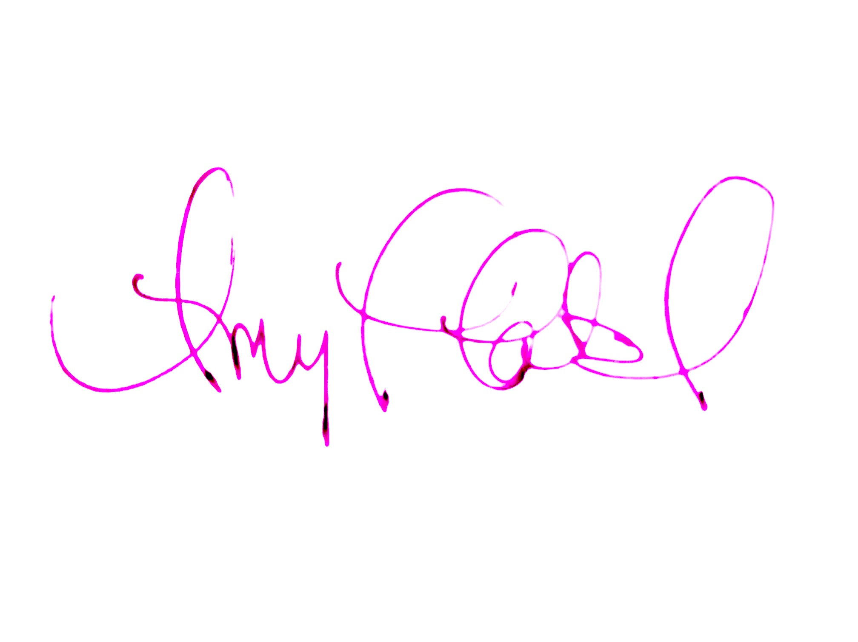

*After you have read the policies and expectations in this syllabus, please do the FOLLOWING:*

*1) JOIN THE REMIND GROUP using this code on the Remind app (OR text the code to the number 81010)*1st block: @1stdramaJC 4th block: @4thdramaJC

*2)* Mark your calendars for these REQUIRED dates:

| **ADVANCED DRAMA only:**  **District I Trumbauer Festival**   * Sat., Nov. 4 from 9 am- 4 pm   at Huntsville High School  *ADVANCED DRAMA students are REQUIRED to compete with ONE IE (Individual Event).* | **Both INTERM. and ADV. DRAMA:**  **Fall Showcase**   * AFTER SCHOOL REHEARSAL   Monday, Dec. 12 from 3:45-6:00 p.m.   * PERFORMANCE—Thurs., Dec. 14   Call Time 6:00 p.m.  Performance 7:00 p.m. |
| --- | --- |

*3) Fill out this Google Form:*

*Student/Parent Syllabus Agreement*

[*https://forms.gle/WrNyKTa3huYZZYhk8*](https://forms.gle/WrNyKTa3huYZZYhk8)

*4) IF your child plans to fundraise or travel with JCTheatre, you MUST ALSO fill out:* [*https://forms.gle/piCyB9YVwM5CqHrQA*](https://forms.gle/piCyB9YVwM5CqHrQA)

***The full JCTheatre calendar is*** [***HERE***](https://docs.google.com/document/d/1aYkdkfGgIArDwC58KbgG6f2PzPw2Xh3yYTq-g0m3OX0/edit?usp=sharing)***.***

**Course Description:**

**Intermediate Drama**  **(**18 weeks/1 credit) Focuses on the performance aspects of drama such as improvisation, monologues, duets, and ensemble acting. Topics such as staging techniques, pantomime, reader’s theatre and technical theatre will be covered in greater detail, as well as student written monologues, duets and solos.

**Advanced Drama** (18 weeks/1 credit) Focuses on advanced acting techniques including directing, dramatic literature study, and technical theatre components. Students will participate in competition (fall) and perform a one-act play.

**Course Objectives:**

*Students will further learn the fundamentals of theatre, including theatre terms, pantomime, history of theatre, improvisation, acting techniques, character analysis, stage movement, production elements (tech), and playwriting. Students in Advanced Drama will learn these topics in-depth and will take on leadership roles in the production and directing of a play.*

**Classroom Rules and Expectations:**

This class is active. Be prepared to move and go outside when the weather is nice. Be sure to dress to accommodate the weather. Also be sure to wear clothes and shoes that allow for movement. You won’t have to dress out like you are playing a sport, but sometimes you will run or sit/move on the ground.

Students will be expected to perform--improvisation or prepared pieces-- in front of the class almost every day. If a student is scheduled to perform a prepared piece, they must perform on the scheduled day, unless they notify the teacher to make other arrangements.

**Performance Attire:** Students are expected to demonstrate professionalism during performances/auditions by dressing up. [NO writing/graphics. NO t-shirts, hoodies, flannel, sweatpants, athletic pants/shorts or pants with holes.]

**Performance Videos:** Student performances--solo and group--will be recorded and shared with students so that they can reflect on their skill development. These videos will be shared to a class Google folder. Students are NOT to post any other video without permission from the performers in the video.

**Concerning Laptop Utilization:** Student laptops should not be hard-wired to the network or have print capabilities. 2. Use of discs, flash drives, jump drives, or other USB devices will not be allowed on Madison City computers. 3. Neither the teacher, nor the school is responsible for broken, stolen, or lost laptops. 4. Laptops and other electronic devices will be used at the individual discretion of the teacher.

**Grading Policy:**

**Performance/Test** grades will account for 70% of the 9-weeks grade, with the remaining 30% determined by quiz/daily grades. The grading scale is as follows: A 90-100, B 80-89, C 70-79, D 65-69, and F below 65. Grades will be a reflection of mastery of the standards. Class work can be made up and graded for excused absences only. If an absence is unexcused, a zero will result.

**Final Exam** counts for 20% of final semester grade and will consist of a short WRITTEN exam, including personal reflection. [Drama Showcase is NOT the final exam.]

**Weekly ENSEMBLE grades** will be given to reflect each student’s contribution to the ensemble and practice of professionalism. Points will be deducted if a student is on his/her phone, is wearing headphones, is missing from group rehearsal, fails to bring materials or dress for active participation, talks excessively, or in other ways displays a lack of commitment or respect for fellow classmates or teacher/director (per director expectations).

Student official grades are in PowerSchool. IGNORE grades in Schoology except if you see a Schoology grade of 1, that is a code indicating that I left the student a comment in the assignment.

If you have questions about grades, check PowerSchool first, then open the missing/questionable assignments in Schoology to check for comments about any issues (comment examples: “Document will not open for Mrs. Patel.” or “Student did not submit the assignment or did the assignment incorrectly or incompletely.”)

**Make-Up and Late Work Policy:**

Because of the hands-on nature of the class, many daily class activities cannot be made up when a student is absent. However, for daily grades that can be made up, and for all test grades, the student must turn in an excused absence (within three days) in order to receive a grade.

**Course Materials:**

∙ 3 prong/ring folder OR binder ∙ notebook paper ∙ pen or pencil

∙ Clothing that allows for freedom of movement.

**Accommodations:** Requests for accommodations for this course are welcomed from students and parents.

Parents may email [appatel@madisoncity.k12.al.us](mailto:appatel@madisoncity.k12.al.us) to request a unique PARENT CODE that will grant access to ALL of your child’s classes in Schoology.

| **IMPORTANT PERFORMANCE/MEETING DATES:**  **Events that are labeled REQUIRED are MANDATORY events.**  **Failure to perform may result in failing the entire course.** | |
| --- | --- |
| **ADVANCED DRAMA only:**  **District 1 TRUMBAUER FESTIVAL–**   * Sat., Nov. 4 from 9 am- 4 pm   at Huntsville High School  *ADVANCED DRAMA students are REQUIRED to compete with*  *ONE IE (Individual Event).*  *(optional) for ALL JCTheatre students*  *𝇈* All JCTheatre students have the OPTION of  competing in IEs and Group Events.  𝇈 Field Trip to watch One-act Plays  Friday, November 3 from ~8am-5pm  𝇈 STATE TRUMBAUER  Nov 30-Dec 2 at UNA, in Florence, AL.  If a student competes and earns a Superior rating at District Festival, they are *expected*, though not required, to compete at State Trumbauer. The cost will be $200 per student (registration, bus and hotel), DUE no later than November 13. Students will have opportunities to raise these fees or may pay them out of pocket. Students must pay for their own food.  OPTIONAL SENIOR AUDITIONS Thursday night. Info TBA. | **Both INTERM. and ADV. DRAMA:**  **Fall Showcase**  Beginning/Interm./Advanced Drama  students will produce a showcase of their work and talent. Some production elements (set, costumes, props, sound, lighting, hair/makeup) will be the responsibility of the students.   * AFTER SCHOOL REHEARSAL   [MANDATORY 100 point test grade.]  Monday, Dec. 12 from 3:45-6:00 p.m.  *All other rehearsals will be held in class.*     * PERFORMANCE   [MANDATORY 300 point test grade.]  Thursday, Dec. 14  Call Time (report to auditorium) 6:00 p.m.  Performance 7:00 p.m.  Tickets $5 for family, friends and the community. FREE to JCTheatre students  *Failure to perform may result in the student failing the entire course.* |

***The full JCTheatre calendar is*** [***HERE***](https://docs.google.com/document/d/1aYkdkfGgIArDwC58KbgG6f2PzPw2Xh3yYTq-g0m3OX0/edit?usp=sharing)***.***

| **OPTIONAL AFTER-SCHOOL OPPORTUNITIES:**  **These are NOT REQUIRED.**  **THESPIAN SOCIETY:** An honor society for Theatre actors and technicians.  **Meetings during Refuel (Dates will be announced in class.)** Remind code @thesp8070  **Desserts & Drama: Tuesday, September 5 from 6-7pm JC Auditorium**  Info about upcoming trips (State Trumbauer, Alabama Thespian Festival, etc.) and fundraising. *If your child plans to compete at Trumbauer, work backstage on the one-act, or go to ATF, we HIGHLY recommend that you attend this meeting!* Parents can sign paperwork and pay on-site.  **JCTheatre one-act**  **Thursday, November 2**  **6:00 p.m. Individual Event Showcase** (Some Int/Adv students will perform Trumbauer IEs.)  **7:00 p.m. One-act**  (Tickets $5 Students/Adults. FREE to JCTheatre students)  See Mr. Comer for info to become part of JETStex CREW (Set, Props, Costumes, Hair/Makeup, Lighting, Sound)  **ALABAMA THESPIAN FESTIVAL: FEBRUARY 16-17, 2024 Vestavia Hills, AL**  ATF is a two day festival of workshops, auditions, and performances. Students also have the OPTION of competing in IEs, improv face off, tech challenge. COST $200 (registration, bus, hotel), due Dec. 8.  **JCTheatre Spring Full-length**  **JC Open Auditions January 18 from 4-6 [**for minor roles and ensemble]  **Performances April 11-13, 2024** (Tickets $10 Students/Adults. FREE to JCTheatre students)  See Mr. Comer for info to become part of JETStex CREW (Set, Props, Costumes, Hair/Makeup, Lighting, Sound)  **JCTheatre and JetsPress 10Min (10 Minute Play & Film Festival)**  **Thursday, April 18, 2024 7:00 p.m.**  (Tickets $5 Students/Adults. FREE to JCTheatre students)  **JCTheatre Spring Showcase**  **Tuesday, April 30, 2024 7:00 p.m.**  (Tickets $5 Students/Adults. FREE to JCTheatre students) |
| --- |

-------------------------------------------------------------------------------------------

---Have an open mind and a willing spirit!

We learn to express and present ourselves with confidence

and creativity in this class, so it is crucial that students are positive,

encouraging and willing to stretch their comfort zones.---