**Dear Parent/Guardian,**

I look forward to having a great year! I feel fortunate to have your child in my class this semester and hope that you will contact me should you have any concerns about the progress of your child or any aspect of the instruction.

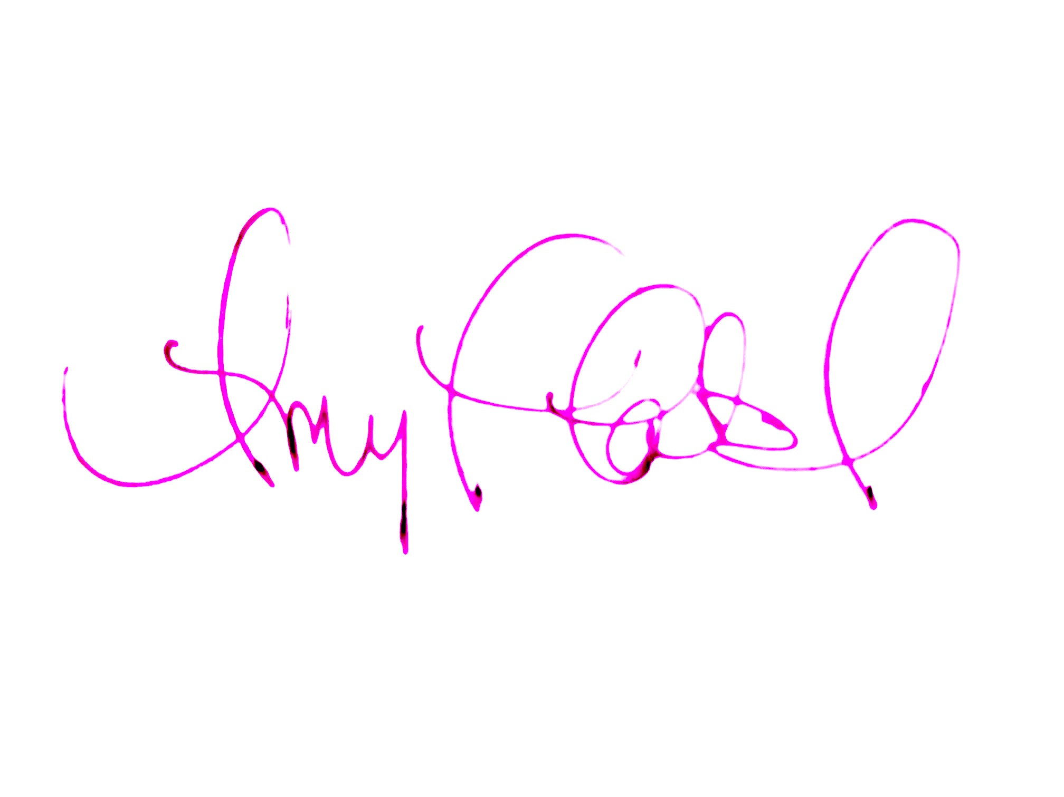

**Thank you,**

***After you have read the policies and expectations in this syllabus, please do the FOLLOWING:***

*1) JOIN THE REMIND GROUP using code*

@jcprod2324 *on the Remind app (OR text the code to the number 81010)*

*2)* Mark your calendars for these REQUIRED dates: (more information in the syllabus)

**Desserts & Drama:**

* **Tuesday, September 5 from 6-7pm JC Auditorium**

**Trumbauer Festival** (DISTRICT AND STATE)

* + DISTRICT 1 TRUMBAUER November 3-4 at Huntsville HS (NOT an overnight trip)
* (potential) STATE TRUMBAUER Nov. 30-Dec. 2 at UNA in Florence, AL (overnight trip)
* (potential) SETC March 13-17, 2024 in Mobile, AL (overnight trip) *NOTE: This is at the end of Spring Break. Notify PATEL ASAP if you already have a trip planned.*

***One-act (Title TBA soon!)***

* Rehearsals: See the [attached calendar](https://docs.google.com/document/d/1aYkdkfGgIArDwC58KbgG6f2PzPw2Xh3yYTq-g0m3OX0/edit?usp=sharing).
* TWO Performances: Thurs, November 2 at 7:00 p.m. at JCHS

AND Friday, Nov. 3 Time TBA at Huntsville HS [Trumbauer One-act Play Festival]

* Possible performances at JC, State Trumbauer and SETC (Mobile, AL), depending on results from District and State Trumbauer festivals.

***Full-length play (Title TBA soon!)*** *JC Open auditions*

* Performances April 11-13, 2024

*3) Fill out BOTH Google Forms:*

*Student/Parent Syllabus Agreement*

[*https://forms.gle/WrNyKTa3huYZZYhk8*](https://forms.gle/WrNyKTa3huYZZYhk8)

*CHARMS data* [*https://forms.gle/piCyB9YVwM5CqHrQA*](https://forms.gle/piCyB9YVwM5CqHrQA)

**Course Description and Objectives:**

**Advanced Production** (18 weeks/1 credit/prerequisite: Audition) Works with the technical theatre class to comprise the complete cast and crew for Fall and Spring plays. Students will experience the complete production process as they prepare, present and critique plays, monologues and duets for public presentation and college scholarship auditions. (BOTH FALL AND SPRING SEMESTERS REQUIRED.)

This class is for the **advanced** and **committed** theatre student. Students will apply performance principles to the production of a one-act play and individual performances.

Students will perform at **various events** in the school and community. They will also perform two Individual Events as well as a **one-act play** which will compete at the **Walter J. Trumbauer Theatre Festival.** They will also audition and begin preparations to perform in the **Spring Full-length play.**

Students will create a **digital portfolio** consisting of their headshot, scripts, video and reflection. This portfolio will count as *their FALL and SPRING Final Exam grades*.

**Classroom Rules and Expectations:**

**See attached ACTOR’S CONTRACT for expectations, after-school requirements and additional fees associated with the course.**

**Guest Artists** will visit class in person and/or online throughout the year to further develop students into becoming confident and able young artists. Students will explore theatre history, theatrical styles, and community and professional theatre. Class time will be spent on stage techniques, script analysis and training in physical and vocal characterization.

**Performance Attire:** Students are expected to demonstrate professionalism during performances/ auditions by dressing up. [NO writing/graphics. NO t-shirts, hoodies, flannel, sweatpants, athletic pants/shorts or pants with holes.]

**Performance Videos:** Student performances--solo and group--will be recorded and shared with students so that they can reflect on their skill development. These videos will be shared to a class Google folder. Students are NOT to post any other video without permission from the performers in the video.

This class is active. Be prepared to move and go outside when the weather is nice. Be sure to dress to accommodate the weather. Also be sure to wear clothes and shoes that allow for movement. You won’t have to dress out like you are playing a sport, but sometimes you will run or sit/move on the ground.

Students will be expected to perform--improvisation or prepared pieces-- in front of the class almost every day. If a student is scheduled to perform a prepared piece, they must perform on the scheduled day, unless they notify the teacher to make other arrangements.

**Grading Policy:**

Performance/Test grades will account for 70% of the 9-weeks grade, with the remaining 30% determined by quiz/daily grades. The grading scale is as follows: A 90-100, B 80-89, C 70-79, D 65-69, and F below 65. Grades will be a reflection of mastery of the standards. Class work can be made up and graded for excused absences only. If an absence is unexcused, a zero will result.

Final Exam counts for 20% of the final semester grade and will consist of a presentation of sections of the student’s Digital Portfolio.

Weekly ENSEMBLE grades will be given to reflect each student’s contribution to the ensemble and practice of professionalism. Points will be deducted if a student is on his/her phone, is wearing headphones, is missing from group rehearsal, fails to bring materials or dress for active participation, talks excessively, or in other ways displays a lack of commitment or respect for fellow classmates or teacher/director (per director expectations).

Student official grades are in PowerSchool. Grades in Schoology are for individual assignments. NOTE: If you see a Schoology grade of 1, that is a code indicating that I left the student a comment in the assignment.

If you have questions about grades, check PowerSchool first, then open the missing/questionable assignments in Schoology to check for comments about any issues (comment examples: “Document will not open for Mrs. Patel.” or “Student did not submit the assignment or did the assignment incorrectly or incompletely.”)

**Accommodations:** Requests for accommodations for this course or any school event are welcomed from students and parents.

**Concerning Laptop Utilization:** Student laptops should not be hard-wired to the network or have print capabilities. 2. Use of discs, flash drives, jump drives, or other USB devices will not be allowed on Madison City computers. 3. Neither the teacher, nor the school is responsible for broken, stolen, or lost laptops. 4. Laptops and other electronic devices will be used at the individual discretion of the teacher.

**Make-Up and Late Work Policy:**

Because of the hands-on nature of the class, many daily class activities cannot be made up when a student is absent. However, for daily grades that can be made up, and for all test grades, the student must turn in an excused absence (within three days) in order to receive a grade.

**Course Materials:**

∙ 3 prong/ring folder OR binder ∙ notebook paper ∙ pen or pencil

∙ Clothing that allows for freedom of movement.

**Accommodations:** Requests for accommodations for this course are welcomed from students and parents.

| **IMPORTANT PERFORMANCE/MEETING DATES: [required]**    **Desserts & Drama: Tuesday, September 5 from 6-7pm JC Auditorium**  Info about upcoming trips (State Trumbauer, Alabama Thespian Festival, etc.) and fundraising.Parents can sign paperwork and pay on-site.  *Adv Prod will perform a preview of the one-act, and some Adv Prod students will perform IEs.*  **Trumbauer Festival** (DISTRICT AND STATE)   * + DISTRICT 1 TRUMBAUER at Huntsville HS (NOT an overnight trip)   Friday, November 3 from ~8am-5pm Field Trip to watch One-act Plays  Saturday, November 4 from 9:00 a.m. to 4:00 p.m. at Huntsville High School.  **IEs (Individual Events)**  **Advanced Production** students are REQUIRED to compete in **TWO IEs.**  [Advanced Drama students are REQUIRED to compete in ONE IE.  All JCTheatre students have the OPTION of competing in IEs and Group Events.]   * STATE TRUMBAUER Nov. 30-Dec. 2 at UNA in Florence, AL. (overnight trip)   Optional Senior Auditions: Thursday Nov 30. Info TBA.  ***One-act***  Adv Production students are REQUIRED to audition/perform in the one-act.   * Rehearsals: See the [attached calendar](https://docs.google.com/document/d/1aYkdkfGgIArDwC58KbgG6f2PzPw2Xh3yYTq-g0m3OX0/edit?usp=sharing). * TWO Performances Thurs, November 2 at 7:00 p.m. at JCHS   AND Friday, Nov. 3 Time TBA at Huntsville HS [Trumbauer One-act Play Festival]   * *POSSIBLE performances, depending on results of District One-Act Play Festival*   *ENCORE performance: Tuesday, November 28 at 7:00 p.m. at JC*  *State Trumbauer performance: Date/Time TBA at UNA Dec. 1 or 2*   * *POSSIBLE performance, depending on results of State One-Act Play Festival*   *ENCORE performance: Date/Time TBA at JC*  *SETC performance (Southeastern Theatre Conf)-*March 13-17, 2024 in Mobile, AL  *NOTE: This is at the end of Spring Break.*  *Notify PATEL ASAP if you already have a trip planned.*  ***Full-length play***  Adv Production students are REQUIRED to audition/perform in the Spring full-length play.   * Performances April 11- 13, 2024 |
| --- |

**OPTIONAL AFTER-SCHOOL OPPORTUNITIES:**

**These are NOT REQUIRED.**

**THESPIAN SOCIETY:** An honor society for Theatre actors and technicians.

**Meetings during Refuel (Dates will be announced in class.)** Remind code @thesp8070

**JCTheatre FALL SHOWCASE: Beginning/Interm./Advanced Drama**

**Thursday, December 14 at 7:00 pm.** Tickets $5. FREE to JCTheatre students

**ALABAMA THESPIAN FESTIVAL: FEBRUARY 16-17, 2024 Vestavia Hills, AL**

ATF is a two day festival of workshops, auditions, and performances. Students also have the OPTION of competing in IEs, improv face off, tech challenge. COST $200 (registration, bus, hotel), due Dec. 8.

**SETC (Southeastern Theatre Conf): March 13-17 in Mobile, AL--** Workshops and performances from across the southeast. Juniors/ Seniors audition for universities. COST varies depending on the number of students. Payment DUE in January. *NOTE: If the one-act places in the TOP 2 at State Trumbauer, it will progress to SETC. ALL Advanced Production students will be REQUIRED to perform.*

**JCTheatre and JetsPress 10Min (10 Minute Play & Film Festival)**

**Thursday, April 18, 2024 7:00 p.m.**  (Tickets $5 Students/Adults. FREE to JCTheatre students)

**JCTheatre Spring Showcase**

**Tuesday, April 30, 2024 7:00 p.m.**  (Tickets $5 Students/Adults. FREE to JCTheatre students)

-------------------------------------------------------------------------------------------

---Have an open mind and a willing spirit!

We learn to express and present ourselves with confidence

and creativity in this class, so it is crucial that students are positive, encouraging and to stretch their comfort zones.---

Parents may email [appatel@madisoncity.k12.al.us](mailto:appatel@madisoncity.k12.al.us) to request a unique PARENT CODE that will grant access to ALL of your child’s classes in Schoology.

**ACTOR CONTRACT**

1. **REHEARSALS AND PERFORMANCES: Advanced Production class** requires commitment TO the attached calendar of dates. THESE DATES ARE MANDATORY!!
2. **PRODUCTION FEES**: Because of the costs of producing a play, students will be responsible for paying/raising the following funds:**FALL$200 DUE Fri, Sept 29**

**SPRING $200 DUE Fri, Feb. 2**

**To cover t-shirt, meals for late night rehearsals, guest artists, rights/royalty fees, promotional materials and technical needs for the one-act play.**

*NOTE: Production Fees do NOT cover costs for SETC or ATF.*

***Fundraising questions can be directed to jamesclemenstheatre@gmail.com***

Any student in the James Clemens Theatre program will be physically ACTIVE in class and at rehearsals. This activity includes but is not limited to stretching, running, creative movement, climbing platforms, stilt walking, stage combat, building/moving set pieces, focusing light fixtures, or setting up sound equipment.

EXPECTATIONS FOR SAFETY:

* Students MUST follow classroom safety/behavior rules and directors’ verbal directions.
* Students will NOT engage in horseplay or unsafe behavior in the theatre/backstage areas.

EXPECTATIONS FOR PROFESSIONALISM:

* Be *present* for all required rehearsals. On time. Ready to work.
* Bring a pencil and script/music to every rehearsal.
* Stay on task and be attentive during rehearsals and independent rehearsal time. Never leave during a rehearsal, even to use the restroom, unless you specifically ask permission.
* Learn lines to dialogue/lyrics by stated deadlines.
* Put personal relationships aside to work as a team for the good of the show.
* Have a positive attitude, open mind and willingness to work.  Theatre is a collaboration.
* Contribute ideas and energy at appropriate times.
* Follow guidelines of the Directing Team and anyone they have procured to help.
* Write down all notes given by the Directing Team and say “Thank You” after every note.
* Provide written notification at least 24 hours before any missed rehearsal.
* *If you miss more than TWO rehearsals, you may be recast.*
* *Attend EVERY rehearsal AND CLASS during the last two weeks. These weeks are crucial.*

REMEMBER...

* Students who do NOT adhere to the above expectations may be recast without notice.
* Actors may be personally responsible for parts of their own costume.
* The Director will make final choices pertaining to role(s).
* All rehearsals and shows are a school function; thus, all school policies regarding the use of tobacco, drugs, and alcohol apply and will be strictly enforced.
* *Theatre is a collaborative art and my classmates depend on me. In addition, as an actor I have three tools: mind, body and voice. As a technician, I must stay clear-headed and focused in order to work safely. Thus, I will refrain from partaking of alcohol, tobacco, or drugs inside OR outside of school*.

The director reserves the right to make any necessary adjustments to the attached schedule. Adjustments will be announced at least one week before they take effect. Students with questions about grades are encouraged to contact the teacher. Attendance and Academic Misconduct policies of Madison City School Board will be enforced.