**JAMES CLEMENS Powder Puff Football Event permission slip**

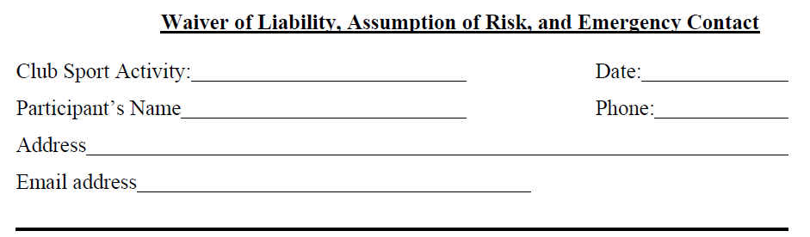

**GRADE ______ T-shirt size ______________**

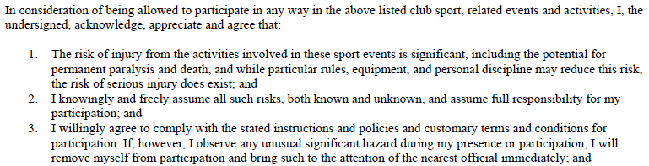

**4. I, for myself and on behalf of my heirs, assigns, personal representatives and next of kin, hereby release, indemnify and hold harmless(“Release”) James Clemens High School (JCHS) and their officers, officials, agents and /or employees, other event participants, sponsoring agencies, sponsors, advertisers and Madison City Board of Education and its officers and employees with respect to any and all injury, disability, death, or loss or damage to person or property, to the fullest extent permitted by law.**

I understand, agree and acknowledge that some activities may be of a hazardous nature and/or include physical and/or strenuous activity. Understanding this, I state that I have no medical condition or impairment that might inhibit my safe and active participation in the above listed activity. In addition, I understand that JCHS does not provide medical insurance coverage for activity participants and that any applicable medical insurance must be provided individually by such participants. In the case of injury or medical emergency and in the event participant, or their parent or guardian cannot respond at the time of emergency, JCHS has permission to seek, administer, or have administered whatever first aid or emergency medical care deemed necessary for participant’s welfare, and it is understood that participant, and not JCHS, shall be responsible for any and all charges for such health care services regardless of whether participant’s medical insurance would cover such charges.



