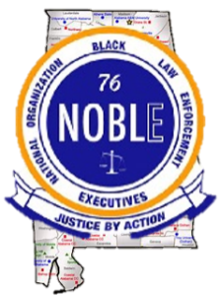
National Organization of Black Law Enforcement Executives
Alabama Chapter
P.O. Box 13846
Birmingham, Alabama 35202

February 23, 2026

TO: City of Madison Alabama Schools

Subject: The Alabama Chapter of NOBLE Scholarship Program

Greetings,

The Alabama Chapter of NOBLE, the National Organization of Black Law Enforcement Executives, will offer ten (10) scholarships to young men and women interested in pursuing a career in law enforcement or a related field. Scholarships are offered to high school seniors, and we believe that a graduating senior from the Madison City high schools would benefit from this opportunity.

NOBLE has created programs designed to institute change in the lives of young men and women in an environment where they are cultivated and motivated to thrive. Committed to a holistic approach, our signature programs are in the areas of mentoring, education, leadership, and safety.
We are hopeful deserving students from Madison City Schools will apply and ultimately win a scholarship. This will underscore the vision of our chapter leaders to have a positive impact on the next generation of leaders. Students can apply for the scholarships at the Alabama Chapter of NOBLE website at www.alabamachapternoble.org. The website will include the scholarship guidelines, and procedures. The deadline for submission is Friday, April 17, 2026.

If there are any questions, please feel free to contact Captain (Ret.) Marion “J.R.” Bulluck at (256) 651-8733 or the scholarship committee via email at bac@noblenatl.net. We will answer your questions at our earliest convenience. We look forward to hearing from you.

Sincerely,

Michael A. Williams

Michael A. Williams
Alabama Chapter of NOBLE, President

